**EDGE COMPUTING**

**Author’s Name: Murli Talreja**

**Co-Author’s Name: Naman Adlakha**

**Co-Author’s Name: Kashishpruthi**

**Department of Computer Science Engineering**

**University of Petroleum Energy Studies Dehradun, India**

**ABSTRACT:**

The development of Internet of Things (IOT) technologies advances has given potential to continuous monitoring and control of environment in our every day to day life. In manufacturing industry, the development of assembling assets underway coordination’s regularly influences the general effectiveness. The development of Internet of Things (IoT) has made a significant effect on establish smart manufacturing workshop and following applications, anyway a, developing pattern of information amount that created from huge, heterogeneous and bottomed manufacturing resources objects pose challenge to centralized decision. The rapid development in the field of medical and computer technologies, the healthcare system has an interesting topic for both the academia and industry. In the field of Self-driving vehicles, the combination of automobiles with autopilot systems, enable intelligent and safe driving systems. We will start with the discussion about the definition of edge computing and its core advantages of edge computing platform. We propose a general system for edge figuring stage. The role of disseminated stockpiling the board frameworks in building edge figuring stage is explained in detail. The interest for advanced media administrations is expanding as the quantity of remote memberships is developing exponentially. Later on, we will introduce a review on ongoing advances in portable edge registering and content storing, including reserving inclusion and removal arrangements, the conduct of the reserving framework, and storing streamlining dependent on remote systems. Later on, we will also be compared edge, fog, and cloud computing. There are two major causes in security of IOT application are severe resource constraints and insufficient security design. The integration of Cloud, Fog and Edge Computing are to seen in VANETs.

**Keyword**:Internet of Things(IoT) and Vehicular ad-hoc networks (VANETs).

**INTRODUCTION:**

As of late, the Internet of Things (IoT) development has achieved broad improvement, which has propelled the headway of keen gadgets. IoT smart devices can detect and screen the dynamic natural condition of the vitality utilization side. While building a judicious model, the characteristic of IOT circumstance in which data shows up progressively in the stream and the law of the data may change consistently ought to be considered. By the day’s end the prescient model should have adaptable getting ready and update procedures. To address the above issues, a short-term energy prediction system for IoT situations dependent tense figuring and streaming handling is proposed. A true contextual investigation of energy consumption and energy production prediction is introduced to confirm the possibility and productivity of the proposed framework. In view of this framework, the energy center can predict energy consumption and make appropriate creation arrangement ahead of time and better compose energy generation. This exploration is motivated by a world-driving climate control system maker situated in the Pearl River Delta of China.

It possesses a mechanical park which agglomerates different upstream and downstream firms for better asset sharing and coordinated effort. The fast improvement of IoT gives answers for handling the area following issues. There are ongoing attempts to automate area following on assembling assets utilizing IoT advances, encompassing Global Positioning System (GPS), RFID, Bluetooth and mix of different advances. Advanced mobile phone situated following arrangements utilizing distributed computing limit picks up prevalence as of late, anyway the following center ought to be moved from individuals to objects. Furthermore, GPS do perform remarkably in open air situations and broadly utilized in everyday life.

In result, the helper detecting structure named ECASS is made to give exact vehicle localization information in the region of oneself driving vehicle subordinate tense enrolling, when it can't decisively discover near to vehicles simply using the camera and radar. We propose an edge registering based structure to help self-driving vehicles to accomplish exact close by vehicle localization and following when self-driving vehicles can't precisely detect the general condition. As of late, self-driving vehicles have pulled in wide thought from both industry and the insightful world because of its security and traveling efficiency. Specifically, with the expansion in the quantity of vehicles, the harmed people and passing in auto collisions are additionally expanding. As a system in future vehicles, autopilot will decrease the road accidents induced by these lines and thus improving the road safety.

It principally comprises of three stages. Firstly, the self-driving vehicles changes the path as per the arranged direction. Besides, it drives along the surpassed vehicle at a recommended parallel separation. At long last, it will come back to the first path before the overwhelmed vehicle. Larger part of research takes a shot at this issue has concentrated on the arranging or forecast of the overwhelming direction.

But, with the development of our infrastructure, people are getting forward to continue to improve the level of consumption. Almost certainly, some close to home touchy data will be spilled, and lawbreakers will utilize them when client look through data on the site. In any case, numerous encryption calculations have been assaulted by programmers, with the goal that encryption calculations can't ensure the security of individual data totally. In this way, how to ensure the security of individual data during the time spent inquiry is a genuine test. There are three types of computing used now-a-days in IOT devices. Following are them:

* **CLOUD COMPUTING**
* **FOG COMPUTING**
* **EDGE COMPUTING**

**1.Cloud Computing**: Cloud computing is the on-request accessibility of computer system resources, particularly data storage and registering power, without direct dynamic administration by the client. Cloud computing is the delivery of registering administration-including servers, storage, database, organizing, programming, examination and insight-over the internet (“the cloud”) to offer quicker development, flexible resources, and economies of scale.

**2.Fog Computing:** Fog Computing is a decentralized registering foundation in which information, figure, storage and applications are found somewhere between the information source and the cloud. Fog computing encourages the activity of process, storage, and networking services between end gadgets and cloud computing data centers.

**3.Edge Computing:** Edge cloud is changing the manner in which information is being dealt with, handled, and conveyed from a huge number of gadgets around the world. The dangerous development of web associated gadgets the IOT alongside new applications that require ongoing registering power, keeps on driving edge-figuring frameworks. Quicker systems administration advances, for example, 5G remote, are taking into account edge computing frameworks to quicken the creation or backing of constant applications, for example, video handling and examination, self-driving vehicles, man-made reasoning and mechanical autonomy, to give some examples.

In this table we are comparing cloud computing, fog computing, and edge computing on different aspects:

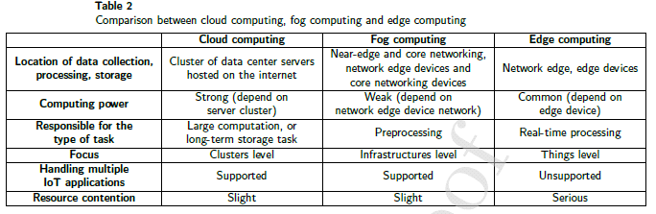

**LITERATURE REVIEW:**

In smart cities, smart energy management and control in business areas is a significant issue. A short-term energy prediction system applying the edge computing architecture is proposed for efficient energy prediction for the IoT consumption and production Environment. In the fig 1: There are four phases of framework information securing and combination, occasion information age, situation model establishment and forecast. As we can see the fig 1: The work in these four stages is progressive. As indicated by this component, we relegate the work to three layer: information obtaining and combination are prepared in the perceptual hubs with restricted computational force, occasion information Generation is acted in the directing hubs of the upper layer after information total, lastly situation model foundation and forecast are acted in the focal server.

In a pilot business area in Shanghai, China, a vitality organization assumes responsibility for the stockpile of all cooling and warming vitality in places of business, shopping centers and mechanical stops in the region. The vitality organization controls a vitality place that produces both warming and cooling vitality and a pipeline arrange for shipping vitality. Then, the vitality organizations additionally screen an assortment of ecological data of the vitality utilization side by differing keen gadgets. As we can see in the fig: 2 The vitality community Consists of a warming vitality plant, a cooling vitality plant and a triple era plant, which together produce the necessary Heating and cooling vitality for the business area. Warming and cooling vitality are put away in the water. The vitality loaded water that streams out of the vitality community, is moved to the vitality utilization end through the channel organize, and is in the long run moved back to the vitality place after the consumption.[1]

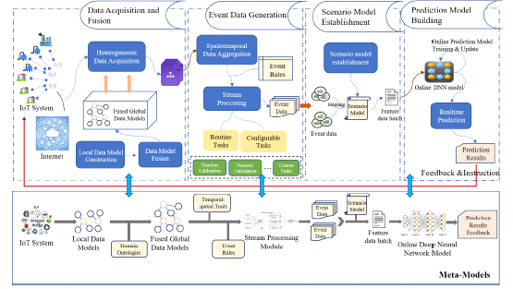

**FIG 1: THE FRAMEWORK OF THE SHORT-TERM ENERGY PREDICTION SYSTEM. [1]**

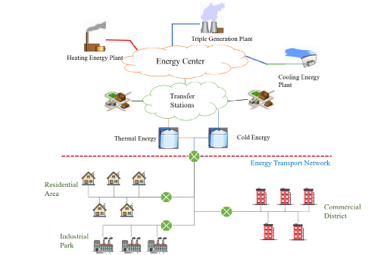

**FIG: 2 THE ARCHITECTURE OF REGIONAL INTELLIGENT ENERGY SYSTEM. [1]**

With the objective of proposing a thought, valuable and usable following design, there are a few vital contemplations. As far as undertaking necessities, fabricating assets are mentioned and headed out from plant to plant inside the mechanical park. In the fig 3: it is shown that Indoor and outside conditions are changed every now and then. Likewise, fabricating assets may move from mechanical production system to sequential construction system among different shop floors, which makes the issue progressively confused. Hence, the following arrangement should fulfill the necessity of shared following in multi-celebrated indoor and outside condition. We propose an IoT edge processing empowered shared following design. Right now, are three sections: [4]

**The front-end**-Auto-ID, sensors and actuators are sent at the front-finish of the innovation structure.

**Close end -** Fixed edge entryways sent in close end condition viewed as "stepping stools" for spanning the availability among digital and physical world.

**Far-end**-Cloud server conveyed at far-end side. It gets the handled information from all edge portals in the specific time window for incorporated. preparing

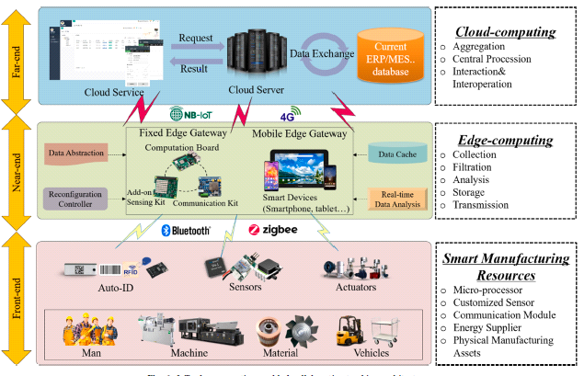

**FIG: 3 IOT EDGE COMPUTING ENABLED COLLABORATIVE TRACKING ARCHITECTURE. [2]**

These days, the traffic condition turns out to be progressively entangled in cities. Along these lines, there exist a few basic difficulties for self-driving vehicles to manage different sorts of traffic situations. For instance, oneself driving vehicle can be effortlessly hindered by the truck or transport in front or behind, as appeared in Fig. 4, in which case oneself driving vehicle is going behind the truck. At that point, the radar or camera mounted on the highest point of oneself driving vehicle can't recognize and find any obstruction in area 1, due to be hindered by the truck in front. Subsequently, one driving vehicle can't decide the movement ling state for the following minute since it can't precisely see the general condition. The customary technique that self-driving vehicles embrace is to follow the truck or transport in front at a decreased speed. Hence, this component will bring about substantially more time utilization and traffic clog, along these lines bringing about more pollution [9].

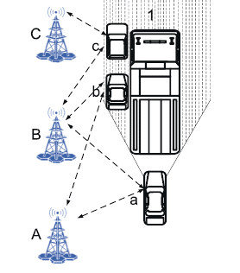

**FIG: 4 THE SCENARIO WHEN THE SELF-DRIVING VEHICLE IS BLOCKED [4].**

With the fast improvement of the autopilot method, self-driving vehicles has pulled in considerable consideration from both industry and the scholarly world. Dominant part of accessible writing has concentrated on the equipment structure,

For example, vehicle borne radar and camera, calculation configuration identified with the data combination, and vehicle direction arranging. How-ever, most direction arranging calculations depend on the suspicion that radar, camera, and IMU can see nature around oneself driving vehicle. In any case, in genuine rush hour gridlock scenes the vehicle might be obstructed by the truck or transport ahead or behind, the radar or camera incorporated inside the vehicle can't detect the general situations precisely. Moreover, GPS based limitation exactness can't guarantee the wellbeing for programmed driving. In this manner, we join self-driving vehicles with edge processing to acknowledge close by vehicle location and limitation when self-driving vehicles are somewhat or even totally hindered by trucks or transports [9].

With the advancement of economy, individuals keep on improving the degree of utilization. All things considered, some close to home touchy data will be spilled, and hoodlums will utilize them when client look through data on the site. Notwithstanding, numerous encryption calculations have been assaulted by programmers, with the goal that encryption calculations can't ensure the security of individual data totally. Hence, how to ensure the security of individual data during the time spent inquiry is a genuine test today so we propose a cross breed filtration suggestion framework dependent on protection saving in edge registering (HFRS-PP). This figure: 5 shows the HFRS-PP model isn't just to meet the client's prerequisites for security and precision of the outcomes, yet in addition improve the system burden and deferral. This System comprises of an untrusted cloud server-side, many confided in edge server-sides and many confided in customer sides. For the danger model, we accept that an aggressor who is conceivably hacking as a cloud server or might be a cloud server organization without an expert specialist controls the cloud server. [10] Edge registering stages for web clients incorporate AWS Greengrass, Microsoft Azure IoT, Baidu BIE, and so forth. These open stages are chiefly founded on the upsides of their own administrators, and their fundamental business targets are web clients. AWS Greengrass is an edge registering stage from Amazon with administrations of local processing, informing, information storing, synchronization and ML Inference for associated gadgets of clients. AWS Greengrass for the most part comprises of AWS Lambda and AWS IoT Core. AWS Greengrass acquires the elements of "Gadget Shadow" in past item AWS IoT: "Gadget Shadow" goes about as virtual reinforcement of genuine gadgets, reserves the condition of neighborhood gadgets, tracks and records the condition of edge gadgets, and synchronizes state data to distributed computing communities while moving information to the cloud.[18]

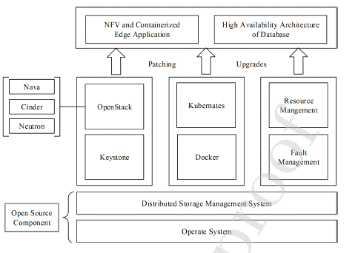

**FIG: 5 FRAME WORK OF EDGE COMPUTING PLATFORM [6].**

The joining of a Cloud-Fog-Edge Computing in VANETs is the answer for handle complex calculation, give portability support, low dormancy and high data transmission. Every one of them serves various capacities, yet in addition supplements each other so as to upgrade the exhibition of VANETs. As shown in the fig 6: Despite the fact that the joining of Cloud, Fog and Edge Computing in VANETs tackles noteworthy difficulties, this system design needs instruments required for assets and availability the executives as it controls the system in a decentralized way. The forthcoming answer for take care of these issues is the enlargement of Software Defined Networking (SDN) right now. Programming Defined Network (SDN) is a promising decision in overseeing complex systems with insignificant expense and giving ideal asset use. SDN offers a worldwide information on the system and furthermore a programmable system engineering by empowering the effectively plan and system deployment [4].

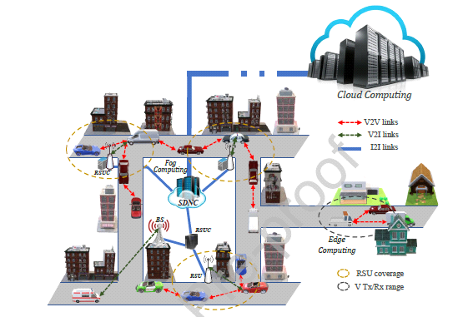

**FIG: 6 TOPOLOGY ARCHITECTURE OF SDN-VANETS USING CLOUD, FOG AND EDGE COMPUTING [10].**

**RESULT:**

**RESEARCH ARTICLE**: We have drawn a diagram Number of articles vs. years. This figure shows that from the year 2010 the research articles is increasing every year continuously. In this article the proposed architecture and figure and implementation method are given:

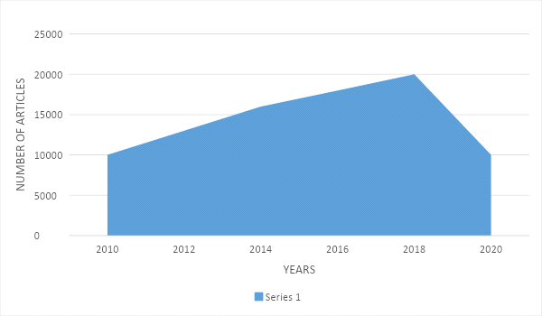

**FIG 7: RESEARCH ARTICLES INVOLUTION**

**Review Articles:** We have drawn a diagram Number of articles vs. year. In this article the review of the implementation and architecture are given it is increasing continuously every year:

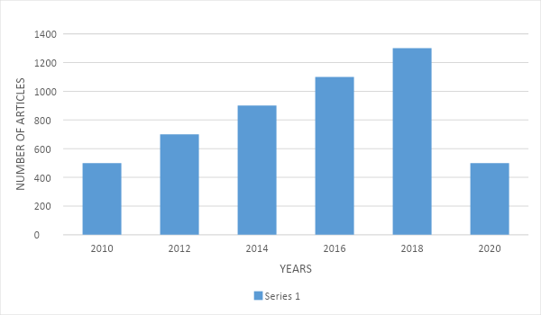

**FIG 8: REVIEW ARTICLES INVOLUTION**

**Mini Reviews:** We have drawn a diagram Number of articles vs. year. In this article short reviews are given about the system and idea which are under process and we can see that this reviewis continuously increasing every year:

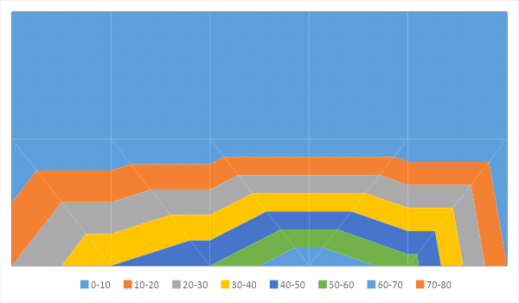

**FIG 9: MINI REVIEW INVOLUTION**

**EDGE COMPUTING PLATFORM ARCHITECTURE:** After deep studies on edge computing we proposed an edge computing framework architecture:

In this architecture the data is being collected by all the sensors and actuators and then all the data will send to the process of filtration and deep analysis. In this process data is being go through a deep analysis and the false data should be filtered. It will reduce the load on database and processing system. After this process the data will be send to the collection proxies. Further to the following process like data validation, metadata annotation, and security etc. Then it will go the virtual IOT devices for local data processing and then at last to the access control polices. After going through all these processes, the valuable data is stored on cloud.

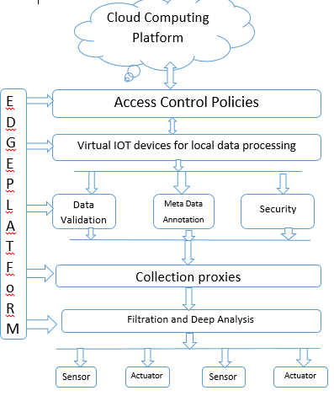

**FIG 10: EDGE COMPUTING PLATFORM ARCHITECTURE**

**ACKNOWLEDGE:** The author and co-author would like to thank you to Miss Anushree Sah Class Coordinator of Computer Science Department (Cloud computing Virtualization and Technologies), Universityof Petroleum Energy Studies Dehradun.

**REFERENCES:**

* Z. Fu, F. Huang, K. Ren, J. Weng, and C. Wang. (2017) “Privacy-preserving smart semantic search based on conceptual graphs over encrypted
* outsourced data.” IEEE Transactions on Information Forensics and Security 12 (8): 1874–1884.
* T. Song, R. Li, B. Mei et al. (2017) “A privacy preserving communication protocol for IoT applications in smart homes.” IEEE Internet of
* Things Journal 4 (6): 1844–1852.
* R. Li, T. Song, N. Capurso et al. (2017) “IoT applications on secure smart shopping system.” IEEE Internet of Things Journal 4 (6): 1945–1954.
* T. Song, N. Capurso, X. Cheng et al. (2017) “Enhancing GPS with lane-level navigation to facilitate highway driving.” IEEE Transactions on
* Vehicular Technology 66 (6): 4579–4591.
* X. Xiao, C. Chen, A. K. Sangaiah et al. (2017) “Cenlocshare: a centralized privacy-preserving location-sharing system for mobile online social
* networks.” Future Generation Computing Systems, to be published, doi: 10.1016/j.future.2017.01.035.
* H. Shen, G. Bai, M. Yang et al. (2017) “Protecting trajectory privacy: a user-centric analysis.” Journal of Network and Computer Applications
* 82: 128–139.
* X. Zheng, G. Luo, and Z. Cai. (2018) “A fair mechanism for private data publication in online social networks.” IEEE Transactions on Network
* Science and Engineering, to be published, doi:10.1109/TNSE.2018.2679483.
* [8] M. Furini and V. Tamanini. (2015) “Location privacy and public metadata in social media platforms: attitudes, behaviors and opinions.”
* Multimedia Tools and Applications 74 (21): 9795–9825.